18.81: With

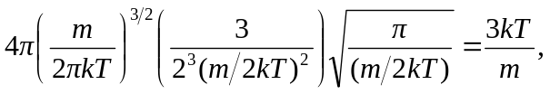

which is Eq. (18.16).

